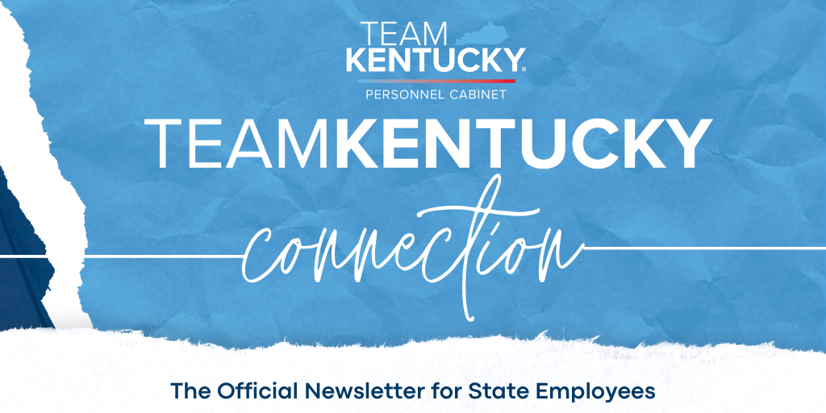
Fall 2023
Featured News    Governor's Budget Proposals  Proposed Salary Increases for State Employees  "I have some more good news when it comes to how our administration prioritizes you, our outstanding public servants. You're hearing from me directly today that in my upcoming state budget proposal, I'm recommending yet another raise for state employees." - Gov. Andy Beshear  Click the image above to hear more about Governor Beshear's proposed increases for state employees.  Open Enrollment  Open Enrollment is October 9 – October 27, 2023. You are not required to re-enroll in health, dental, vision, or life insurance for 2024, but we encourage you to review your plan options and ensure the plan(s) you currently have still meet your needs. If you do not enroll during the Open Enrollment period, you will remain in the same health, dental, vision, or life insurance plan options and coverage levels as you have in 2023. You must enroll every year if you have the Waiver General Purpose HRA and a Flexible Spending Account. To find out more details, go to kehp.ky.gov and click on Open Enrollment for 2024.  Enrolling is easy! Log into KHRIS.ky.gov, click on Open Enrollment and start the process.  Let’s go electronic!  Tax season will be here before you know it and most of us want to file right away. Get quicker access to your W-2 later by choosing to receive it electronically now!  Log into KHRIS ESS and select the Election for Online W-2 tile. When the screen appears, select “New Election” which will then display your options for the current tax year. Select “Receive W-2 online.” You’ll be asked to confirm your election by selecting “OK.” Four clicks is all it takes!  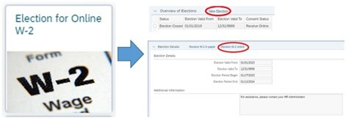  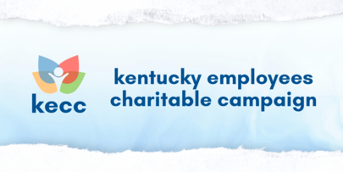  We are thrilled about all of the KECC events happening around the state! Stay up-to-date with the latest events, both virtually and in-person by clicking the link below.  KECC Events  Through this link, you can also learn more about the KECC partner charities and the impact that you can make through just $1 per pay period! Log in to KHRIS to enroll in payroll deduction or to process a one-time donation.  MyPURPOSE Refresh  The Personnel Cabinet is excited to release a refreshed welcome screen within MyPURPOSE! Along with creating a brighter look and minimizing wasted space, the next time you log in you’ll notice the following changes, as outlined and shown in the screenshot below:  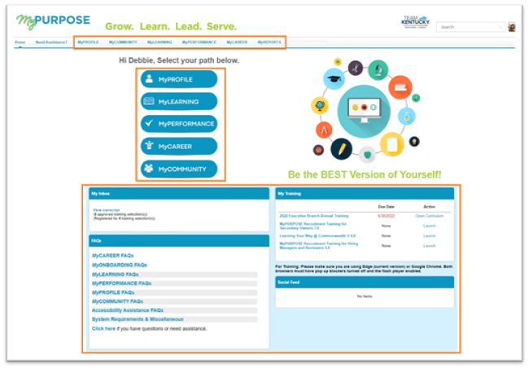  - The navigation options at the top of the screen have been renamed and match the new buttons, which have replaced the previous path tiles.  - Profile = MyPROFILE  - Connect = MyCOMMUNITY  - Learning = MyLEARNING  - Performance = MyPERFORMANCE  - Open Opportunities = MyCAREER  - Your worklists have been moved towards the top of the screen for easier access.  Please note that any MyPURPOSE system training will continue to reflect the original welcome screen until we complete all updates; however, all functionality remains the same.    The Commonwealth of Kentucky’s general election will be held on Tuesday, November 7, 2023. All registered voters are eligible to vote in the 2023 general election in every county of the  Commonwealth. To view a copy of each county’s sample ballot, please visit the Secretary of State’s website at GoVote.ky.gov.  All employees entitled to vote, who are otherwise scheduled to work during the hours that the polls are open, and who request leave in advance, shall be granted up to four (4) hours of voting leave (VOTE) to cast their votes in person. In addition, employees who choose to vote absentee may be granted this leave if a request is made in advance of the day they appear before the clerk to request an application for or to execute an absentee ballot in person or by mail.  Learn how you can get on track and stay on track before and after retirement.  Whatever retirement adventures await you, we have resources and tools to help you in your journey. Join us now through December 3, 2023, to:  - Learn how your retirement plan can help you maximize your retirement adventures  - Visit our smoothie truck for interactive trivia and test your knowledge  - Dive deeper into how to prepare for and live in retirement with topics that can help you throughout your career  - Get hands-on experience with our planning tools in the Resource Studio  - Celebrate your efforts in taking steps to improve your financial health and future  - Access live and on-demand webinars  - Enroll in or manage your retirement plan  - Connect with a Retirement Representative  Take a step to prepare for retirement. Visit our Virtual Adventure Center Benefit Fair today!  Investing involves market risk, including possible loss of principal. No investment strategy or program can guarantee to make a profit or avoid loss. Actual results will vary depending on your investment and market experience. Information provided by your KDC Retirement Specialist is for educational purposes only and is not intended as investment advice. Retirement Specialists are Registered Representatives of Nationwide Investment Services Corporation, member FINRA, Columbus, Ohio.  NRM-22179KY-KY (09/23)  Interested in exploring other career opportunities?  Current employees are always welcome to look out for other employment opportunities within the Commonwealth, whether it’s at their own agency or another. But did you know that if you decide to apply to a vacancy, you must do so within MyPURPOSE? Attempting to apply from the public Careers website, without logging into MyPURPOSE, will hinder your experience with potential account issues and you’ll miss out on any internal mobility opportunities!  So if you’re on the Careers website, be sure to select the green “Current Employee” tile. From there, you’ll be prompted to log into MyPURPOSE. Once logged in, select the MyCAREER button, to see all competitive and internal mobility opportunities.  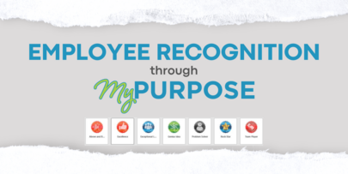  Badges and feedback can be provided within MyPURPOSE as a form of employee recognition. These badges can be submitted as peer-to-peer, manager-to-employee, and even employee-to-manager!  Click this link to view a step-by-step guide for awarding badges through MyPURPOSE!  November is National Adoption Month!  Did you know: The Commonwealth of Kentucky has been recognized by the Dave Thomas Foundation for Adoption as one of the Best Adoption-Friendly Workplaces in the government industry!  Currently, we offer $5,000 ($7,000 for children with special needs) in the form of a reimbursement, a stipend, or combination thereof to help cover adoption expenses as well as offset future medical or educational expenses.  We are thrilled to offer our adoption benefits and hope that our employees continue to utilize this program. Click here to learn more about your eligibility or to apply for these benefits.    GAA Commemorative Bricks  This year, the Personnel Cabinet received 176 nominations for the Governor's Ambassador Awards, which covered 2,028 state employees. We are excited to announce that a brick with each winner's name was placed on the walkway in front of the Thomas D. Clark Center for Kentucky History to commemorate their contributions to the Commonwealth. You can read more about the winners and their achievements by clicking here.    Governmental Services Center Upcoming Training Opportunities  *GSC: Managing Work Relationships  - GSC Virtual Classroom: Understanding Your Social Style - October 25, 2023  - GSC Virtual Classroom: Adapting Your Social Style - November 8, 2023  *GSC Leadership Basics  - GSC Virtual Classroom: Leadership Basics – Foundations November 1, 2023  - GSC Virtual Classroom: Leadership Basics – Roles November 15, 2023  - GSC Virtual Classroom: Leadership Basics – Communication November 29, 2023  *Register first for the curriculum, complete any prerequisites, and then register for the individual sessions!  - GSC Virtual Classroom: Brainstorming December 6, 2023  - GSC Virtual Classroom: Choosing to be Accountable December 13, 2023  - MyPURPOSE User Group Meeting for Training Administrators and Coordinators 10 AM – 11:00 AM October 18, 2023  - MyPURPOSE Training Administrator (New administrators only) 8:30 AM – 12:00 PM November 21, 2023  - MyPURPOSE Training Coordinator (New coordinators only) 1:00 PM 4:00 PM November 21, 2023 | What's in this edition?  - Governor's Budget Proposals  - Open Enrollment Reminder  - Electronic W-2  - Kentucky Employees Charitable Campaign  - MyPURPOSE Refresh  - Election Day Information  - Deferred Comp Virtual Benefit Fair  - Internal Career Opportunities  - Employee Recognition Badges  - National Adoption Month  - GAA Winner Commemoration  - State Holidays  - Upcoming Virtual Classrooms & Webinars  - Autumn Safety Tips  Get Started on MyPURPOSE Today!  - Access over 2,000 online training courses and webinars.  - Connect with team members virtually.  - Apply for career opportunities.  CLICK HERE TO ACCESS PERSONNEL EVENT CALENDAR  BLOOD DONATIONS NEEDED!  Click here for Blood Donation Information
  
  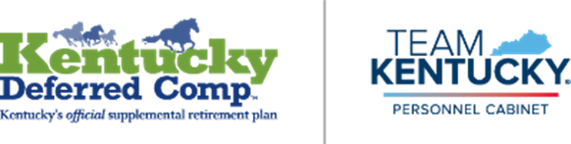
  
  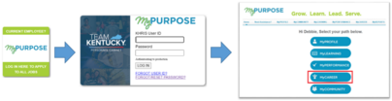
  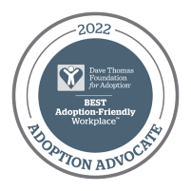
  2023 Holidays for State Personnel
  State offices shall be closed and state employees shall be given a holiday on the following days:
  - Friday, November 10 - Veterans Day
  - Thursday & Friday, November 23, 24 - Thanksgiving
  - Monday & Tuesday, December 25, 26 - Christmas
  - Friday & Monday, December 29, January 1 - New Year's​
  Autumn Safety Tips
  Each season brings its own joys and unique potential hazards. Please see the below seasonal safety tips to have an amazing autumn!
  Mayo Clinic Fall Safety Tips
  
  